https://dev.azure.com/nvoicepay/Nvoicepay/_boards/board/t/MACH%20Team/Stories/?workitem=83134
Vendor follows Retention Token Link AND is already signed up for ACH
- IsAllowed = 1 in [dbo].[VendorPaymentAcceptance] table
Vendor follows Retention Token Link AND is NOT already signed up for ACH
- IsAllowed = 0 in [dbo].[VendorPaymentAcceptance] table

Steps to reproduce:
- locate a Master Vendor accepts master card (41e567e-ea42-4a68-9053-a239d32a832d)
- Run query update [dbo].[VendorPaymentAcceptance] table, run the query for already signed up for ACH
update [dbo].[VendorPaymentAcceptance]
set IsAllowed = 1
where VendorID = 'a41e567e-ea42-4a68-9053-a239d32a832d' and VendorPaymentAcceptanceID = '966434'
- Run postman to get the retention enrollment URL: GET https://dev-api-achmanagement.nvoicepay.com/api/enrollmenttoken/retention/MasterVendor/a41e567e-ea42-4a68-9053-a239d32a832d
- Open the enrollment URL in a browser:
https://dev-portal-enrollment.nvoicepay.com/token-enrollment?token=dd1ea469-7cd0-4a49-a78c-264b430d853c
- Follow steps to complete enrollment
Ticket
https://dev.azure.com/nvoicepay/Nvoicepay/_boards/board/t/MACH%20Team/Stories/?workitem=83173

Run sql to find qualify test data

Select top(10) * from ZpVendors.dbo.Vendor v LEFT Join ZpTransactions.dbo.VendorPaymentAggregation pa on v.VendorID = pa.MasterVendorGuid LEFT Join ZpVendors.dbo.VendorPaymentAcceptance vpa on vpa.VendorID = v.VendorID where v.AcceptsACH = 0 AND vpa.PaymentTypeID = 1 AND vpa.IsAllowed = 0 and v.AcceptsMasterCard = 1 and v.AcceptsNVPPaymentCard = 0 and (pa.AggregatePayments = 0 OR pa.AggregatePayments IS NULL)
Steps to reproduce:
- Locate a Master vendor accepts master card and ACH, and hasn't enrolled ACH (IsAllow = 0 in [dbo].[VendorPaymentAcceptance] table). (C38C3183-6DC7-41D2-B78C-99A089A04038)
- Log in Ops tool kit, search for the Master vendor
- Click the pencil icon, select ACH
- Copy link should be available
- 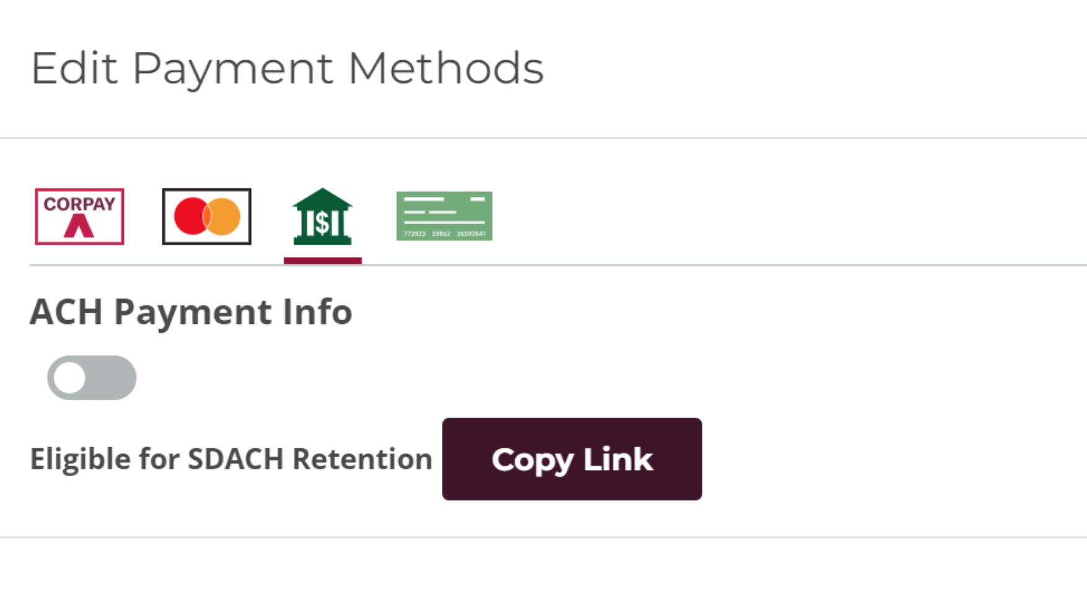
5. Click the button, then open a browser, paste the URL, follow steps to enroll
6. Once enrollment is completed successfully. ACH icon should be visible for the vendor (ACH is not available before the enrollment)
